CSE420
Samuel Marrujo
Professor Yu
Lab 01

Draw01
In this part of the lab, it was a simple drawing of a rectangle and a triangle. Using the rectangle function and polylines, I was able to accomplish this task successfully. Here are my results for this program:
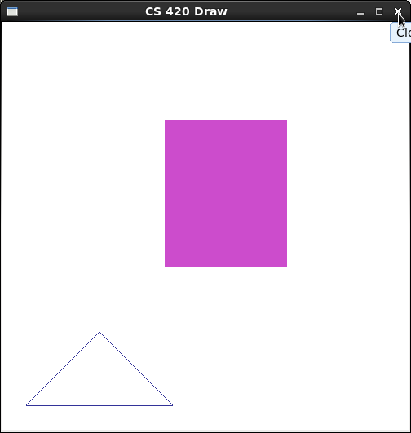

//draw.cpp : demo program for drawing 3 dots, two lines, ploylines, rectangles
#include <GL/glut.h>

//initialization
void init( void )
{
glClearColor( 1.0, 1.0, 1.0, 0.0 ); //get white background color
glColor3f( 0.0f, 1.0f, 0.0f ); //set drawing color
glPointSize( 8.0 ); //a dot is 4x4
glMatrixMode( GL_PROJECTION );
glLoadIdentity(); //replace current matrix with identity matrix
gluOrtho2D( 0.0, 500.0, 0.0, 500.0 );
}

void display( void )
{
glClear( GL_COLOR_BUFFER_BIT ); //clear screen

glColor3f ( 0.2, 0.2, 0.6 );
glBegin( GL_LINE_STRIP );
glVertex2i( 30, 30 );
glVertex2i( 120, 120 );
glVertex2i( 210, 30 );
glVertex2i( 30, 30 );
glEnd();

glColor3f( 0.8, 0.3, 0.8 ); //bright grey
glRecti( 200, 200, 350, 380 );
glFlush(); //send all output to screen
}
Mouse_key
Lastly, in the mouse_key program, we are to modify the program to how we want it. So, I decided to change the brush size and the color, then decided to draw a happy face afterward! Here are my results for this program:

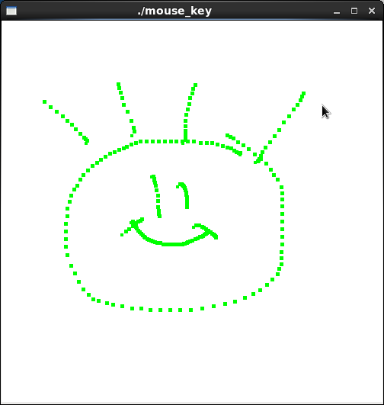

//mouse_key.cpp
#include <GL/glut.h>
#include <stdlib.h>

#define screenHeight 500

//initialization
void init( void )
{
glClearColor( 1.0, 1.0, 1.0, 0.0 ); //get white background color
glColor3f( 0.0f, 0.0f, 0.0f ); //set drawing color
glPointSize( 4.0 ); //a dot is 4x4
glMatrixMode( GL_PROJECTION );
glLoadIdentity();
gluOrtho2D( 0.0, 500.0, 0.0, 500.0 );
} //init

void display()
{
glClear( GL_COLOR_BUFFER_BIT | GL_DEPTH_BUFFER_BIT );
glFlush();
}

void drawDot( int x, int y )
{
glBegin( GL_POINTS );
glVertex2i( x, y ); //draw a points
glEnd();
} //drawDot

void myMouse( int button, int state, int x, int y )
{
if ( button == GLUT_LEFT_BUTTON && state == GLUT_DOWN )
drawDot( x, screenHeight - y );
glFlush(); //send all output to screen
}

void myMovedMouse( int mouseX, int mouseY)
{
GLint x = mouseX;
GLint y = screenHeight - mouseY;
GLint brushsize = 5;
glColor3f( 0.0, 1.0, 0.0 );
glRecti ( x, y, x + brushsize, y + brushsize );
glFlush();
} //myMovedMouse

void myKeyboard ( unsigned char key, int mouseX, int mouseY )
{
GLint x = mouseX;
GLint y = screenHeight - mouseY;
switch( key )
{
case 'p':
drawDot ( x, y );
glFlush();
break;
case 'r':
glRecti ( x, y, x + 20, y + 30 );
glFlush();
break;
case 'e':
exit ( -1 );
default :
break;
}
}

